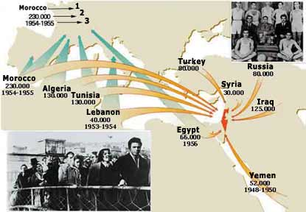
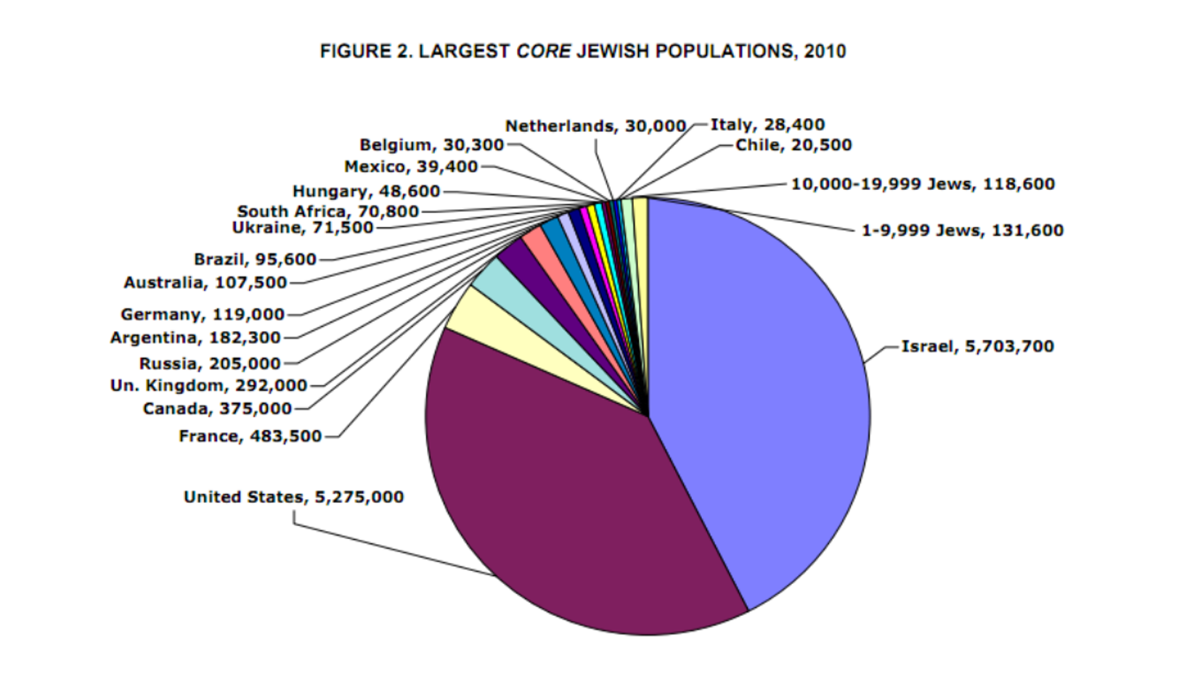

1. Why did Jews want to immigrate to Palestine?
2. How did Jewish immigration to Palestine make Jews feel safe and secure following their persecution in Europe, especially prior to and during WWII?
3. Why would the British restrict immigration to Palestine?
4. “A land without a people, for a people without a land” was commonly used to describe Palestine in relationship to Jewish immigration. How would this encourage Jews to immigrate and how would Jewish immigration to Palestine affect the majority native population?
5. According to the second chart, which two places do the majority of the world’s Jewish population live in currently?

Articles to read:
http://www.myjewishlearning.com/article/jewish-immigration-to-palestine/# http://www.jewishvirtuallibrary.org/jsource/History/mandate.html
http://www.cjpme.org/fs_181

